The Literacy Learning Progressions: Meeting the Reading and Writing Demands of the Curriculum describe the literacy-related knowledge, skills, and attitudes that students need to draw on to meet the demands of the curriculum.  Connected  Level 4  2019  Maths Craft  by Dr Jeanette McLeod and Dr Phil Wilson  The Learning Progression Frameworks (LPF) describe significant signposts in reading and writing as students develop and apply their literacy knowledge and skills with increasing expertise from school entry to the end of year 10.  Overview  This article takes a playful, creative approach to pure mathematics, guiding readers through craft activities that let them explore the properties of Möbius strips and mathematical knots.  A Google Slides version of this article is available at www.connected.tki.org.nz | 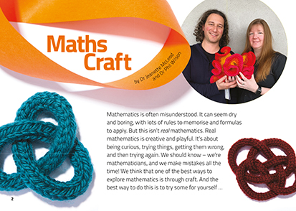
Curriculum contexts

MATHEMATICS and STATISTICS: Geometry and Measurement: Shape  Level 4 – Students will:  - identify classes of two- and three-dimensional shapes by their geometric properties  - relate three-dimensional models to two-dimensional representations and vice versa.  MATHEMATICS and STATISTICS: Geometry and Measurement: Transformation  Level 4 – Students will use the invariant properties of figures and objects under transformations (reflection, rotation, translation, or enlargement). | Key mathematics ideas  - Mathematics is creative and playful.  - Mathematical shapes and knots can be used to create crafts.  - Shapes can be transformations and have the same features but look different.  - Mathematicians play with and extend ideas to look for recurring patterns and relationships.
THE ARTS: Developing Practical Knowledge: Visual Arts  Level 4 – Explore and use art-making conventions, applying knowledge of elements and selected principles through the use of materials and processes. | Key visual arts ideas  - Art can be created using a variety of materials and methods.  - Materials can be formed, manipulated, and transformed to create art works.
ENGLISH: Reading  Level 4 – Ideas: Students will show an increasing understanding of ideas within, across, and beyond texts. | Indicators:  - makes meaning of increasingly complex texts by identifying and understanding main and subsidiary ideas and the links between them  - makes connections by thinking about underlying ideas within and between texts from a range of contexts  - recognises that there may be more than one reading available within a text  - makes and supports inferences from texts with increasing independence.

The New Zealand Curriculum

Meeting the literacy challenges

The main literacy demands of this text lie in the interpretation and application of abstract mathematical concepts as students combine information from the text and photos to carry out the activities. The instructions are given in clear, open language and are well supported by photographs and illustrations. However, in some parts, students need to read long, complex sentences to follow the instructions and explanations. The photos are an important feature of the text as they contain explicit representations of the steps students undertake as they carry out the tasks.  The article is split into two parts, each following a similar structure. The text highlights connections between them.  The following strategies will support students to understand, respond to, and think critically about the information and ideas in the text. | The instructional strategies below support students to meet the literacy challenges of this text. For each strategy, there are links to the relevant aspect of The Learning Progression Frameworks (Reading). The signposts on each of these aspects provide detailed illustrations on what to notice as your students develop their literacy knowledge and skills for different purposes in different curriculum areas.  You may wish to use shared or guided reading, or a mixture of both approaches, depending on the reading expertise of your students and the background knowledge they bring to the text.  After reading the text, support students to explore the activities outlined in the following pages.

INSTRUCTIONAL STRATEGIES

Finding the main ideas  [LPF Reading: Acquiring and using information and ideas in informational text]  Have the students read the title and introduction on page 2. ASK QUESTIONS to orient them to the purpose of this text and to consider the point of view of its writers.  What point are the writers trying to make?  Who are the “we” in the article? Why do you think these people might think this way?  Have the students stand on a continuum, from people who think of mathematics as “dry and boring” to those who think it’s “creative and playful”. PROMPT them to explain their choice, then tell them that you will repeat the activity after the reading, when the writers have had a chance to make their case.  SCAN the article with the students, ensuring they understand the overall structure: an introduction, two examples of different kinds of maths craft, and a conclusion.  Depending upon your students’ needs, you might support them through a first reading. Otherwise, let them work through it independently. Either way, be prepared with materials so they can do the suggested activities as they read. Let them work at their own pace but pause regularly for them to share what they have learned.  Note that a “mathematical knot” is different from an ordinary knot. You may need to clarify that it is a tangled loop with no ends.  DISCUSS why the writers chose these two examples to illustrate their love of mathematics.  What connects these two examples?  What are some similarities between Möbius strips and mathematical knots? What are some differences? | Have the students REVIEW the text, using the information to create a Venn diagram that compares these two types of shapes.  Dealing with unfamiliar vocabulary  [LPF Reading: Making sense of text: vocabulary knowledge]  Create a class chart for students to RECORD the new terms they encounter. As the students read, PROMPT them to illustrate it with examples from their own experiments, preferably through uploading photographs.  Word Definition Illustrations  Generating procedural text and using visual features for deeper understanding  [LPF Reading: Making sense of text: using knowledge of text structure and features]  DISCUSS the two explanations for making a Möbius strip on page 3 (in the text and in the illustrations). DISCUSS which the students found most helpful and ask the students to suggest other ways they could present this information. Work with them to recreate the instructions as a set of procedures. They could use an interactive template, such as the step chart templates on Edraw. Alternatively, they could create an instructional video. When the students are confident, have them work in pairs or independently to put together a procedure for one of the other activities. They could test their instructions with students in another class or with their parents and whānau.

The Learning Progression Frameworks
The Literacy Learning Progressions
Effective Literacy Practice: Years 5–8

Illustrating the key ideas

Mathematics is creative and playful. | 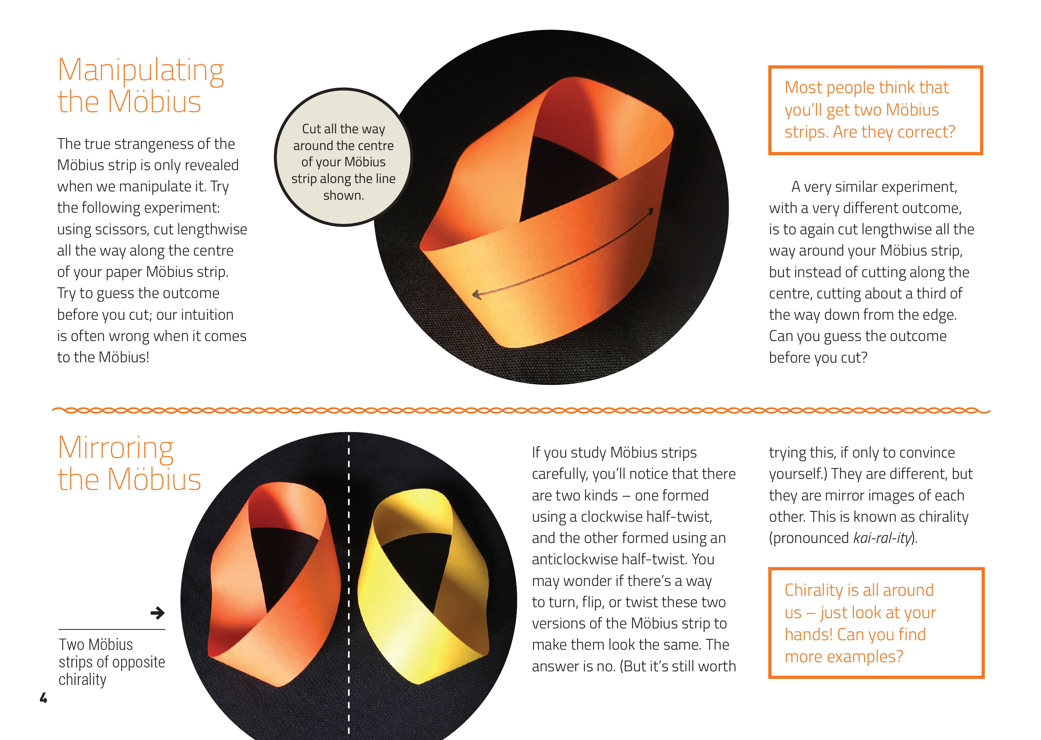  Shapes can be transformations and have the same features but look different.  Art can be created using a variety of materials and methods.
Materials can be formed, manipulated, and transformed to create art works. | 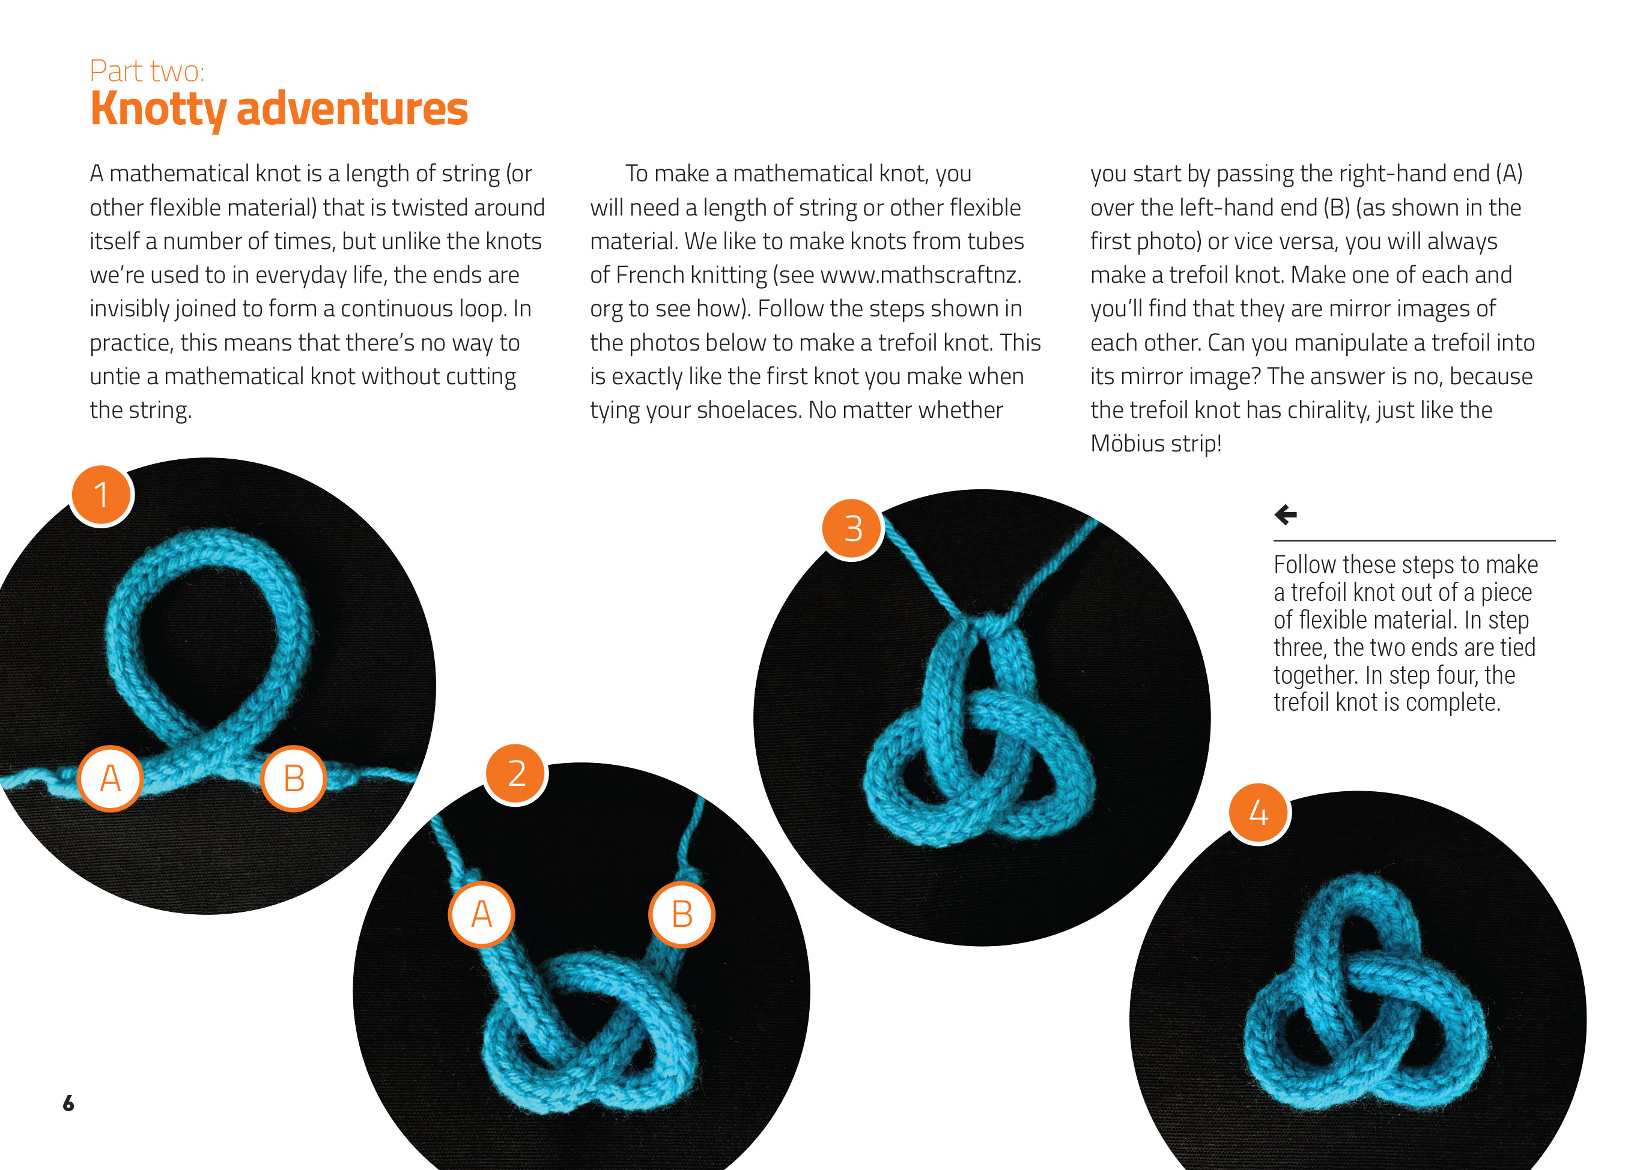

Learning activities – Exploring the
mathematics and statistics and the arts

Activity 1 – Classifying knots  Have the students reread Part two: Knotty adventures.  Present the image below, which is available on Wikipedia Commons:  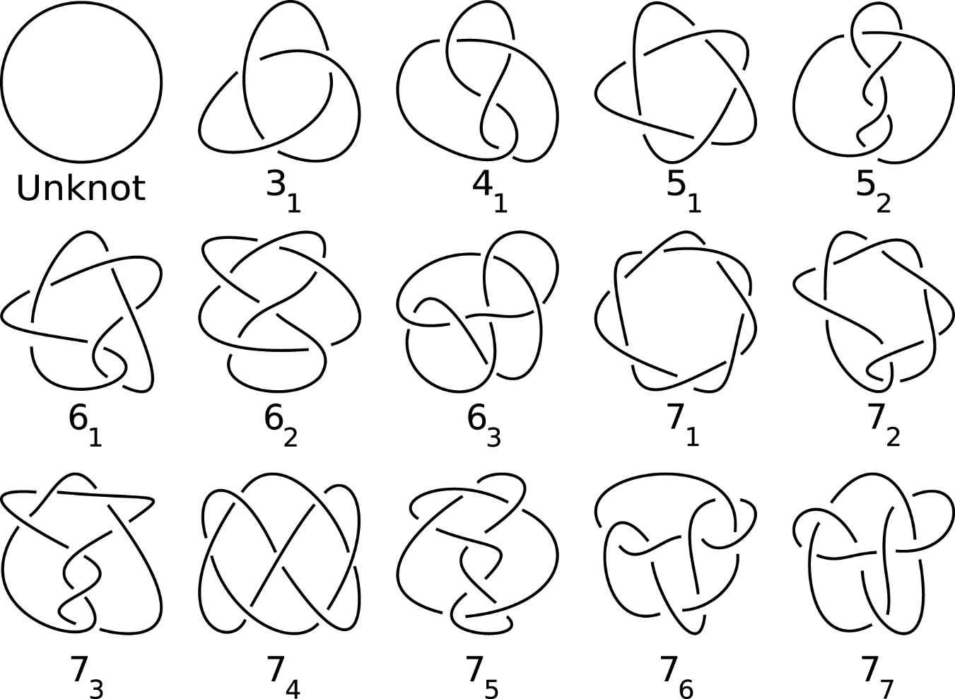  Explain that the image shows all of the different knots that have between 0 and 7 crossings. Tell the students that these are called prime knots because they cannot be made by joining smaller knots together. Joining two or more prime knots forms a composite knot.  Use the Prime Numbers Chart and Calculator on the Maths Is Fun site to clarify the connection between prime and composite knots and prime and composite numbers.  Definition Example  Prime number  Prime knot  Composite number  Composite knot  Prompt the students to compare the prime knots chart with the photographs on page 8.  Which have we already created?  Which would you like to have a go at creating?  Reread the conclusion to remind the students of the connection between prime knots and Möbius strips. The text explains that the boundary edge of a three-twist Möbius strip is a trefoil.  Extending the learning  See the resource links below for more opportunities to explore mathematical knots and Möbius strips from the Maths Craft team and others. | The following activities and suggestions are designed as a guide for supporting students to explore and extend their content knowledge across the learning areas. Adapt these activities to support your students’ interests and learning needs.  Activity 2 – More maths craft  Show the students the video clip “Moebius Strip II 1963 Escher” as an introduction to the way Möbius strips are used in art. The students could go on to explore more examples of Escher’s work, involving other geometrical shapes, such as tessellations. This could be the springboard for them to create artworks of their own.  Have students revisit page 6. Explain that French knitting is itself a mathematical process, involving a series of slip knots. Share the Radio New Zealand interview with Dr McLeod, which is illustrated with examples of maths in this and other crafts.  As a class, investigate other mathematical forms of art. In the School Journal story “Poi”, the central character learns to make poi, a process that includes knotting and plaiting. Using the process described in the story and local expertise, students could make their own. In “Tīvaevae”, another School Journal item, students learn about this art form from the Cook Islands. “I Spy Symmetry!” is a Figure It Out activity that suggests how students can explore transformations and symmetry in the environment and in cultural patterns. If your focus is more on how different cultural traditions are expressed in patterns, there are detailed unit outlines in the visual arts resources listed below.  The Maths Crafts site offers other examples of mathematics involving other craft activities, such as origami and crochet. Local members of the community may be willing to share how knots are part of the arts and crafts that they make.  Activity 3 – Practical maths  Some of your students will have expertise with knots gained in recreational activities, such as sailing or scouting. For others, there may be practical applications in their day-to-day life. The Figure It Out “Knot Tying” activity could be the catalyst for exploring how knots are used to perform tasks and the characteristics of knots that are suitable for different applications.

RESOURCE LINKS

Connected and School Journal  “Poi”, School Journal, Level 2, November 2014  “Ngatu: Keeping the Tradition Alive”, School Journal, Level 2, June 2018  “Tīvaevae”, School Journal, Level 3, April 2013  Figure It Out  At Camp, Level 3, Knot tying: https://nzmaths.co.nz/resource/knot-tying  Level 3, I spy symmetry! https://nzmaths.co.nz/resource/i-spy-symmetry  YouTube  Knot possible – Part 1: https://www.youtube.com/watch?v=SBd1K4YqP5E  Knot possible – Part 2 – The answer: https://www.youtube.com/watch?v=cKYME_8e87w  Moebius strip II 1963 Escher: https://www.youtube.com/watch?v=ZN4TxmWK0bE  Escher style tessellations for primary students: https://www.youtube.com/watch?v=h0F1_qVt_aQ  Other sources  Radio New Zealand: Maths & crafts: Using crochet and origami to teach mathematics: https://www.rnz.co.nz/national/programmes/afternoons/audio/201835180/maths-and-crafts-using-crochet-and-origami-to-teach-mathematics  Maths Craft New Zealand: Resources: http://www.mathscraftnz.org/resources/  Curious Minds: How can origami shape your brain? https://www.curiousminds.nz/stories/how-can-origami-shape-your-brain/ | Wonderopolis: What is a Möbius strip? https://wonderopolis.org/wonder/what-is-a-mobius-strip  Monster sciences: Challenge science experiment: Möbius strips: http://www.monstersciences.com/challenges/challenge-science-experiment-mobius-strips/  The kid should see this: How to make a paper Möbius strip: https://thekidshouldseethis.com/post/17712032055  Smithsonian: The mathematical madness of Möbius strips and other one-sided objects: https://www.smithsonianmag.com/science-nature/mathematical-madness-mobius-strips-and-other-one-sided-objects-180970394/  Brilliant: Knots: https://brilliant.org/wiki/knots/  American Mathematical Society: Knots, molecules, and stick numbers: https://www.ams.org/publicoutreach/knot-signs-for-more-info.pdf  Maths is fun: Prime numbers chart and calculator: https://www.mathsisfun.com/prime_numbers.html  Public domain prime knot chart: https://en.wikipedia.org/wiki/ Prime_knot#/media/File:Knot_table.svg  Ministry of Education. (2007). He papahuia toi Māori: Māori visual culture in visual arts education years 1–6. Wellington: Learning Media.  Ministry of Education. (2007). Pasifika visual arts: A resource for teachers of years 7–10. Wellington: Learning Media.  Edraw: https://www.edrawsoft.com/stepcharts.php

